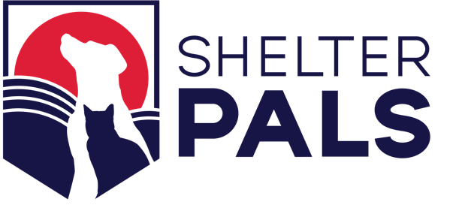

IN-HOME ADOPTION PROGRAM
(FOUNDATIONAL PRINCIPLES)
The Shelter PALS model for In-Home Adoption starts from the proposition that a foster parent acts on behalf of the shelter with respect to the animal the foster is caring for, and so the foster is subject to the same requirements with respect to holding periods and standards of care as the shelter. That is, a foster who is working with a shelter, and who is in possession of an animal the foster has found, need only wait until expiration of the legal holding period and satisfaction of the shelter’s requirements to attempt to locate the animal’s owner, all as determined by state and local law, before the animal may be lawfully adopted out by the shelter and the adopting person (including the foster parent) becomes the lawful owner of the animal.
The Shelter PALS model, in effect, creates a foster/agency relationship between a private citizen who finds or has taken possession of a stray or abandoned animal (the “Finder”) and the local shelter. In this way, the shelter can satisfy any legal obligations it may have vis-à-vis the found animal – an animal who would otherwise be in the physical possession of the shelter. Thus, the Finder becomes a foster parent for the shelter, like any other foster parent.
The Shelter PALS approach reduces the number of animals who need to enter the shelter, and ensures a short turnaround time for animals found/rescued by private individuals (basically the same time they would spend in the shelter). This enhances animal welfare and helps shelters reduce their operating costs, while at the same time ensuring that animals receive the appropriate level of care and remain available for owner redemption for the legally required holding period and when the shelter is attempting to locate an animal’s owner.
With the In-Home Adoption Program, the shelter is involved from the beginning but each animal remains at the Finder’s home. If, after expiration of the holding period and the shelter’s satisfaction of its obligations to attempt to locate the animal’s owner, the Finder would like to adopt the animal, the Finder will be required to go through the same process as any other adopter, in order to ensure that the animal is spayed/neutered, microchipped, and receives any necessary vaccines and licenses. At that time, the Finder also may release the animal to the shelter or continue a non-adoptive foster relationship with the animal.

IN-HOME ADOPTION PROGRAM
(PROTOCOL)
The shelter will have two readily-available documents for the In-Home Adoption Program: a general description/set of guidelines for the In-Home Adoption Program; and an In-Home Foster Agreement, which will govern the relationship between the Finder and the shelter after the found animal is entered into the shelter’s records. These program materials will be made available to the Finder in whatever form is preferred by the Finder.
Upon receiving notice from the Finder that an animal has been found, Animal Control/Animal Services will promptly collect the necessary information to determine if the animal is a candidate for the In-Home Adoption Program. The criteria for determining whether the animal is eligible for the In-Home Adoption Program will be the same as the shelter’s criteria for determining whether a physically impounded animal is eligible for fostering or adoption. If the found animal is an animal that the shelter is not legally required to intake, then the shelter has discretion to decide if it wants to include the animal in the Program. If the shelter determines the animal qualifies, it will enter the animal into the shelter’s recordkeeping program and take steps to attempt to locate the animal’s owner. All other steps in the shelter’s normal intake procedure will also be accomplished in the In-Home Adoption Program.
As soon as possible after the initial contact, Animal Control/Animal Services will visit the Finder’s home to scan the animal for a microchip as required by Food and Agricultural Code Section 31108(c) (dogs) and Section 31751.3(a)(1) (cats), and, if necessary, to photograph the animal. This will ensure that, if an owner is identified through the microchip scan, the shelter can begin its attempts to locate the owner sooner rather than later. That way, the shelter will more likely have satisfied its obligations to attempt to locate the animal’s owner by the time the holding period has expired and the animal will be available for adoption at that time or soon thereafter.
Whether or not the animal has a microchip, the shelter will also immediately begin to “make reasonable efforts to contact the owner and notify him or her that his or her [animal] is impounded and is available for redemption,” as required by Food and Agricultural Code Section 31108(c) (dogs) and Section 31751.3(a)(1) (cats), and to take any other specific measures required by the applicable city/county ordinances. These efforts should be the same as for an animal who was initially physically impounded at the shelter.
During the in-person meeting between Animal Control/Animal Services and the Finder, the Finder will relinquish possession of the animal (so that the microchip scan can be conducted and a photograph taken), the Finder will review and execute the In-Home Foster Agreement, and possession of the animal will then be returned to the Finder. The In-Home Foster Agreement will be very similar to the shelter’s standard foster agreement for an animal who was initially physically impounded at the shelter, unless the shelter chooses to include some preferential terms to incentivize people in the community to participate in the In-Home Adoption Program. The In-Home Foster Agreement will thereafter govern the relationship between the shelter, the animal, and the Finder.
At the end of the legal holding period and upon satisfaction of the shelter’s obligations to try to locate the animal’s owner, the shelter will contact the Finder to schedule an appointment for spay/neuter, microchipping, vaccinations, and licensing if the Finder would like to adopt the animal, or to release the animal to the shelter. It is anticipated that most shelters will provide a “right of first refusal” to the Finder or a Finder’s referral for adoption of the animal – so long as the Finder or the Finder’s referral satisfies the shelter’s generally-applicable eligibility criteria for animal adoption. If the Finder would prefer to keep the animal, but in the role of foster, then nothing need be done.

